Task 1: Simple Analog Input
As you learned in Computer Chapter 10, the Feather board has 6 analog input pins, A0-A5, that have the hardware to convert incoming voltages that can be anywhere in the domain 0-3.3V into corresponding integers. Give or take small errors, the conversion is

where value is the integer returned by reading the value property of the input pin.
In order to use these functions you have to first import the analogio module instead of (or as well as) the usual digitalio module. Then you can tell Feather that you want to use the analog input function of one of these pins by setting it up with
analog_in = analogio.AnalogIn(board.<pin name>)
a) Connect your 100k variable resistor between ground and the 3.3V pin on your Feather and connect the middle pin, the adjustable one, to input A0 on your Feather.
b) Write a short program that reads the analog value once every second and then prints both the raw value and the voltage that you compute from that value. Paste your working, commented, program below.
# Author: Ben Kallus
# Displays the value of the analog input on A0

import board
from time import monotonic
from analogio import AnalogIn

def main():
potentiometer = AnalogIn(board.A0)
while True:
print(potentiometer.value, "is the raw value, and", potentiometer.value * 3.3 / 65535, "is that value converted to volts.")

main()

c) Connect a DVM to pin A0 as well so that you can read the voltage with both the DVM and your Feather. Compare the voltage that you measure on the DVM with the Feather value at several (at least 8) settings of the variable resistor between 0 and 3.3V.
Feather DMM
0.043 0.03
0.24 0.26
0.88 0.90
1.07 1.06
1.62 1.62
2.46 2.43
2.72 2.71
3.27 3.24
d) How accurate is your Feather?
Pretty accurate; it was off by at most 0.03V.

Task 2: Seeing the Light
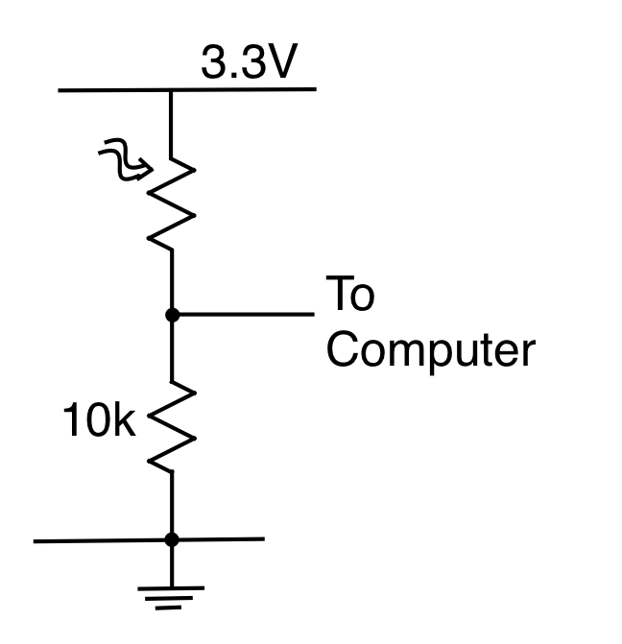
In your supplies you should find some small Cadmium Sulphide (CdS) photoresistors. These are semiconducting devices whose forward resistance falls from a high value in the dark to a low value when they are illuminated. If we put a photoresistor in series with a fixed resistor we can make a voltage divider whose output is a voltage that depends on the amount of light falling on the sensor.
Since the resistance of the CdS cell falls when it is illuminated, it is usually most sensible to wire the divider as shown in the figure on the right, where the CdS is the resistor with the wavy thing beside it. This way the voltage will increase as the light level does.
a) Build two of these and connect their outputs up to two of the analog input pins on your Feather board. Modify your program so that it can print both values.

b) Describe how the voltages depend on light level (you can carry the robot around if you are on a laptop or can shade it with something if not).
One of my photoresistors behaves the way you describe, but the other’s resistance increases as the light level increases. This one has a better range and seems to be more accurate, so I’m going with the reversed one.

c) Explain why the voltage increases as the light level increases and indicate the range of ADC values that you expect to find around as the robot rolls around the room.
The voltage increases as the light level increases because the resistance decreases as the light level increases, so the the voltage drop across the photoresistor decreases.
I expect to see 49632 at the darkest point in the room, and 65520 at the brightest point in the room.

d) Modify your robot rolling program to make its behavior depend on light. For example, you might try to make it always steer towards the brightest light or the darkest. There is a lot of room for you to have fun here. Make clear in the comments to your program what your robot does and how it does it. Note that it still needs to use its whiskers to perform obstacle avoidance.
Paste your working, well-commented, program below. Note that your comments need to be better than usual here because I have not specified what the program should do. That is your job.
# Author: Ben Kallus
# Drives to the darkest area

import board
from pulseio import PWMOut
from time import monotonic, sleep
from digitalio import DigitalInOut, Direction, Pull
from analogio import AnalogIn

MAX_DUTY = 65535

PINL = board.D10 # left
PINR = board.D12 # right
PIN_BUMPER_L = board.A5
PIN_BUMPER_R = board.A3

FREQ = 50 # frequency required for motors

FD_L = 1.6
FD_R = 1.3
BK_L = 1.3
BK_R = 1.7
STOP = 1.505

RIGHT_TURN_TIME = .55

def calculate_duty_cycle(on_time, frequency):
return round(MAX_DUTY * on_time / (1000 / frequency))

def forward(pwmr, pwml):
pwml.duty_cycle = calculate_duty_cycle(FD_L, FREQ)
pwmr.duty_cycle = calculate_duty_cycle(FD_R, FREQ)

def stop(pwmr, pwml):
pwmr.duty_cycle = calculate_duty_cycle(1.5, FREQ)
pwml.duty_cycle = calculate_duty_cycle(1.5, FREQ)

def turn_right(pwmr, pwml):
pwml.duty_cycle = calculate_duty_cycle(FD_L, FREQ)
pwmr.duty_cycle = calculate_duty_cycle(BK_R, FREQ)

def backward(pwmr, pwml):
pwml.duty_cycle = calculate_duty_cycle(BK_L, FREQ)
pwmr.duty_cycle = calculate_duty_cycle(BK_R, FREQ)

def main():
duty_cycle = calculate_duty_cycle(STOP, FREQ)
pwmr = PWMOut(PINR, duty_cycle=duty_cycle, frequency=FREQ)
pwml = PWMOut(PINL, duty_cycle=duty_cycle, frequency=FREQ)

photo = AnalogIn(board.A0)

left_bumper = DigitalInOut(PIN_BUMPER_L)
right_bumper = DigitalInOut(PIN_BUMPER_R)
for bumper in (left_bumper, right_bumper):
bumper.direction = Direction.INPUT
bumper.pull = Pull.UP

prev = 65535
light = 65535
while True:
prev = light
light = photo.value
print(prev, light)
if not (left_bumper.value and right_bumper.value): # If we hit anything, turn right.
print("bumping")
backward(pwmr, pwml)
sleep(1)
turn_right(pwmr, pwml)
sleep(RIGHT_TURN_TIME)
elif prev - light > -50:
print("found a decent direction")
forward(pwmr, pwml)
sleep(.1)
else:
print("have to turn")
turn_right(pwmr, pwml)
sleep(RIGHT_TURN_TIME * 2)
main()

For this part you can use one optical sensor and keep track of your history or two and try to use their information to guide your route or can put several on the robot (I have lots) and try something altogether new.

